**DEPLOYMENT CR ASSET SELLING Phase 2**

**S0218256, X0222847**

Bug Description

1. User Click Detail Memo Auction
2. Query is being executed to proceed data buyer
3. Data “OfferPriceAmount” is null
4. Data null cannot be proceeded because it hasn’t been covered
5. Error Shown

Root Cause

1. 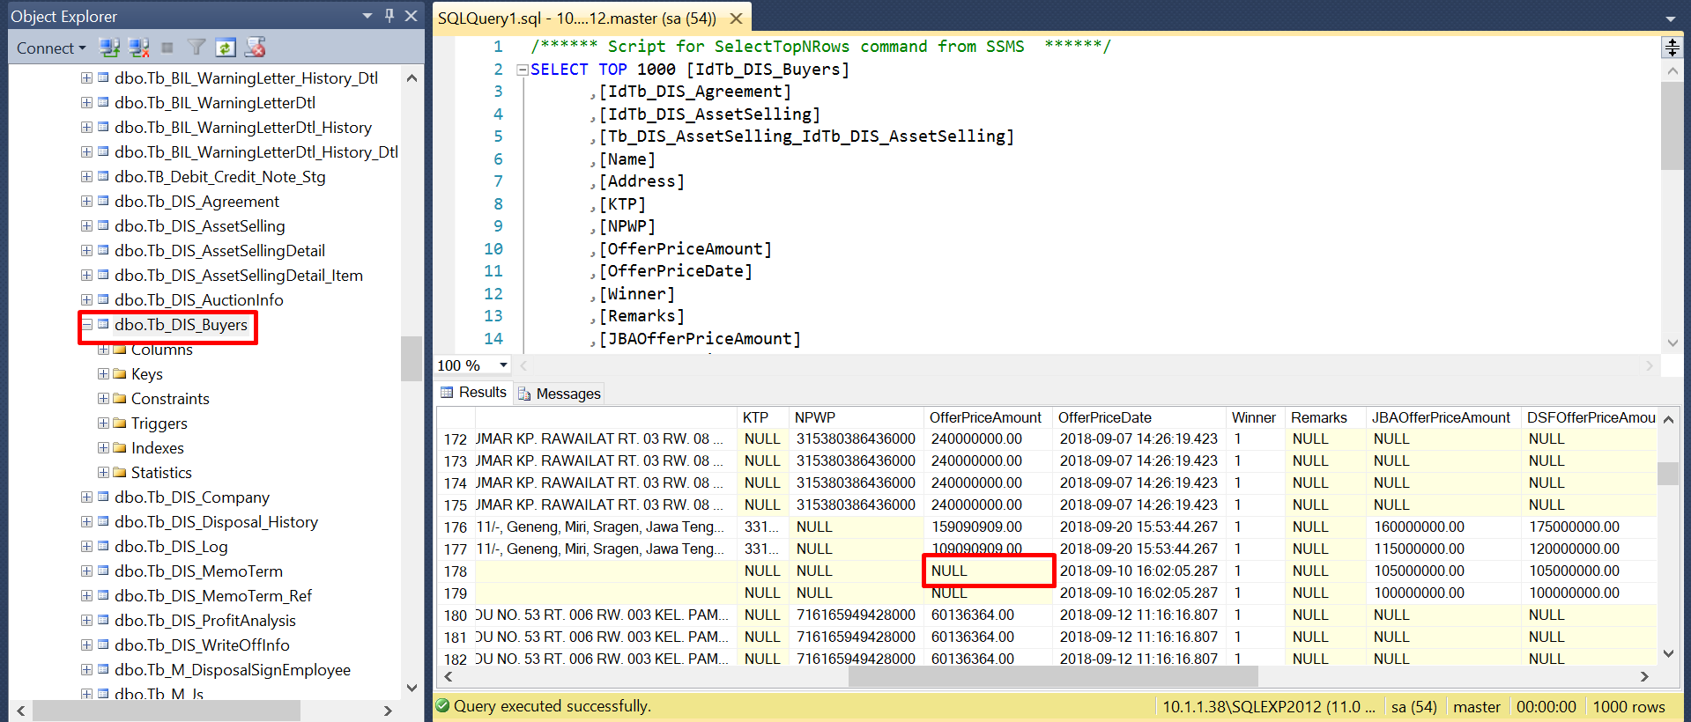Tb_DIS_Buyers (OfferPriceAmount is null)

Fixing Root Cause

1. Change OfferPriceAmount from null to 0 for existing data in the 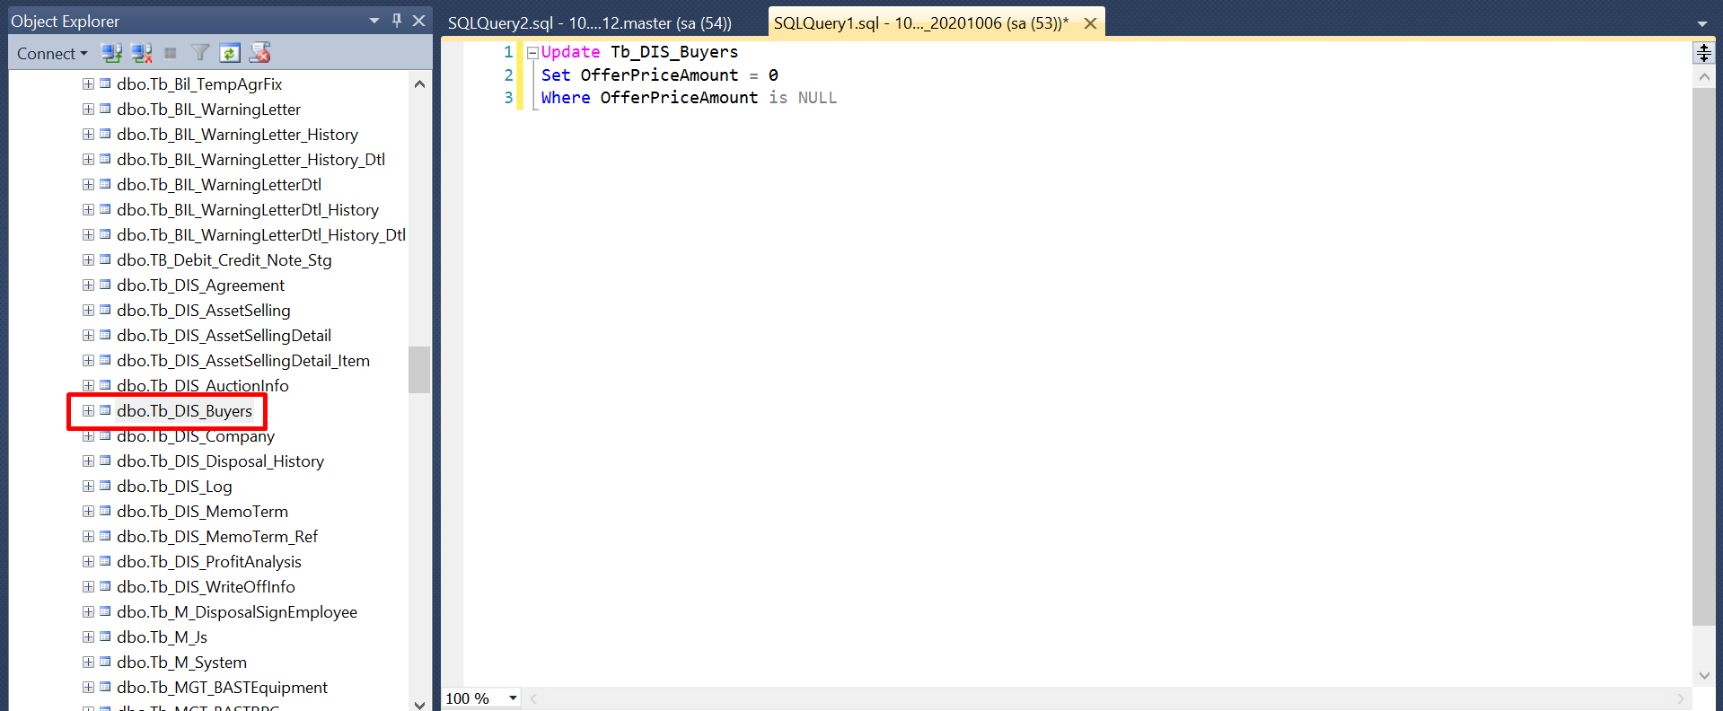Tb_DIS_Buyers table
2. 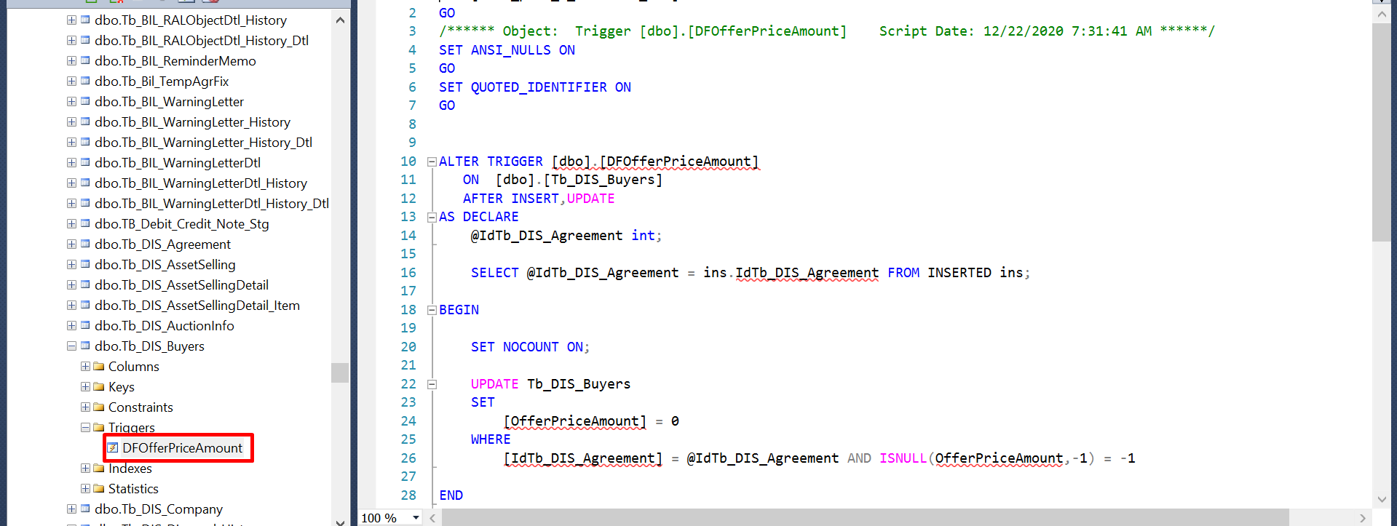Create a Tb_DIS_Buyers table triger to solve the new OfferPriceAmount data that is inputted has a null to be 0

Lesson Learn

1. If there's finding outside scope CR, make sure to check the risk first to prevent the error in the future.
2. If we agree to proceed the finding during UAT Phase, then always test full cycle since we have made new additional development.

**EVIDENCE**

UAT Evidence

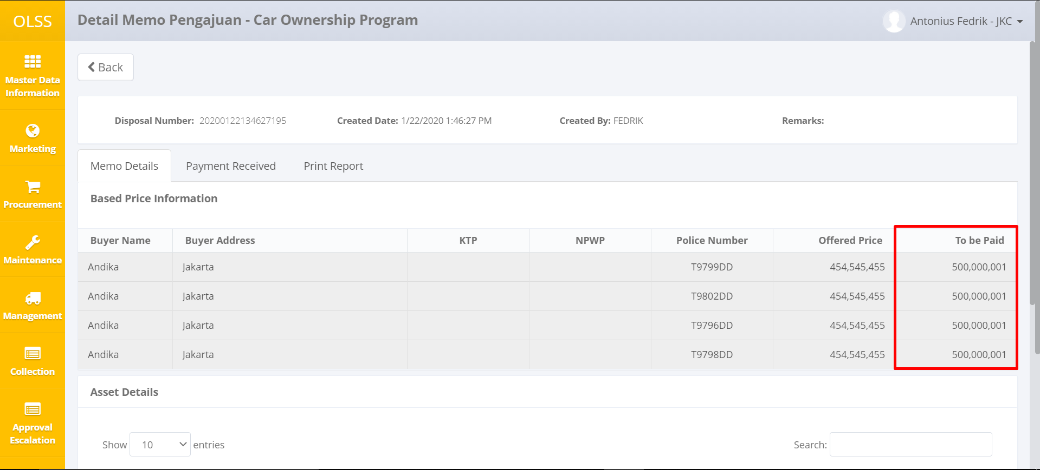

Before Change (UAT Phase)

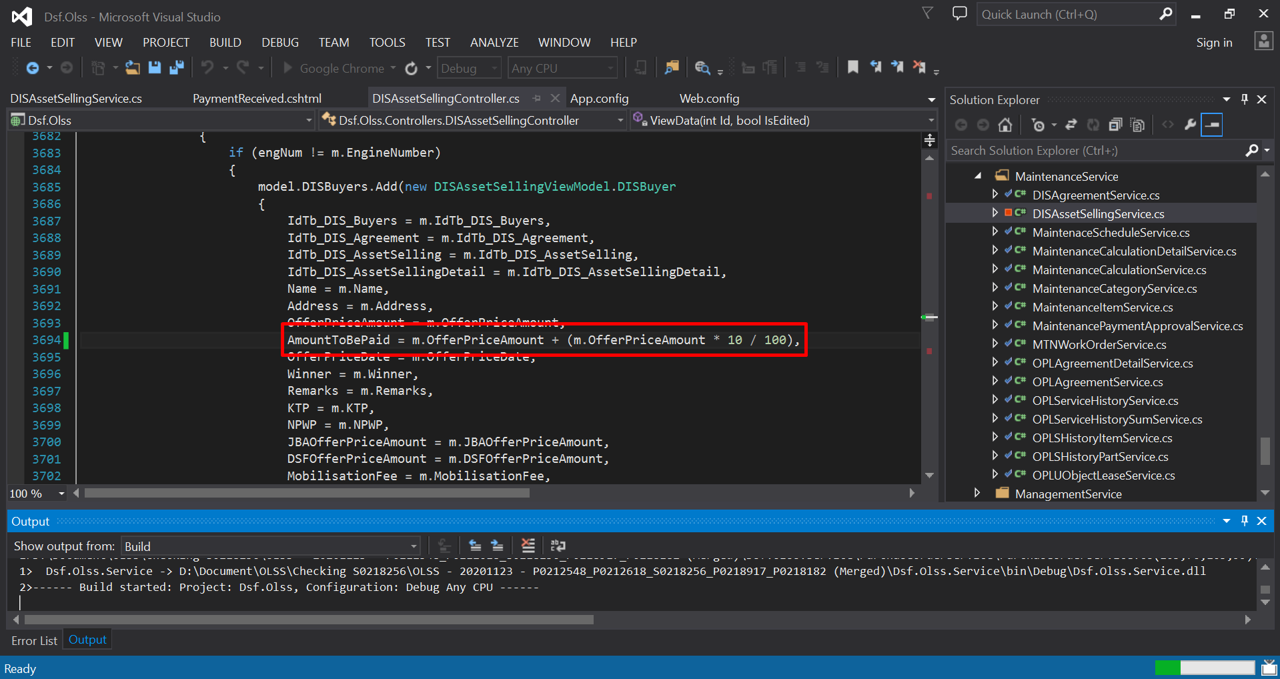

After Change (UAT Phase)

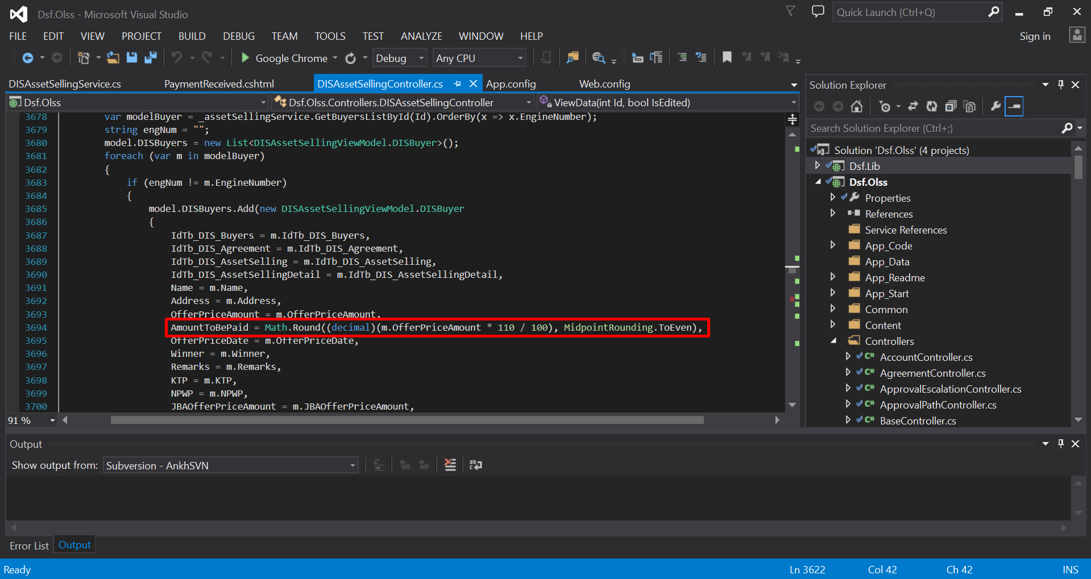

Result UAT Fixing

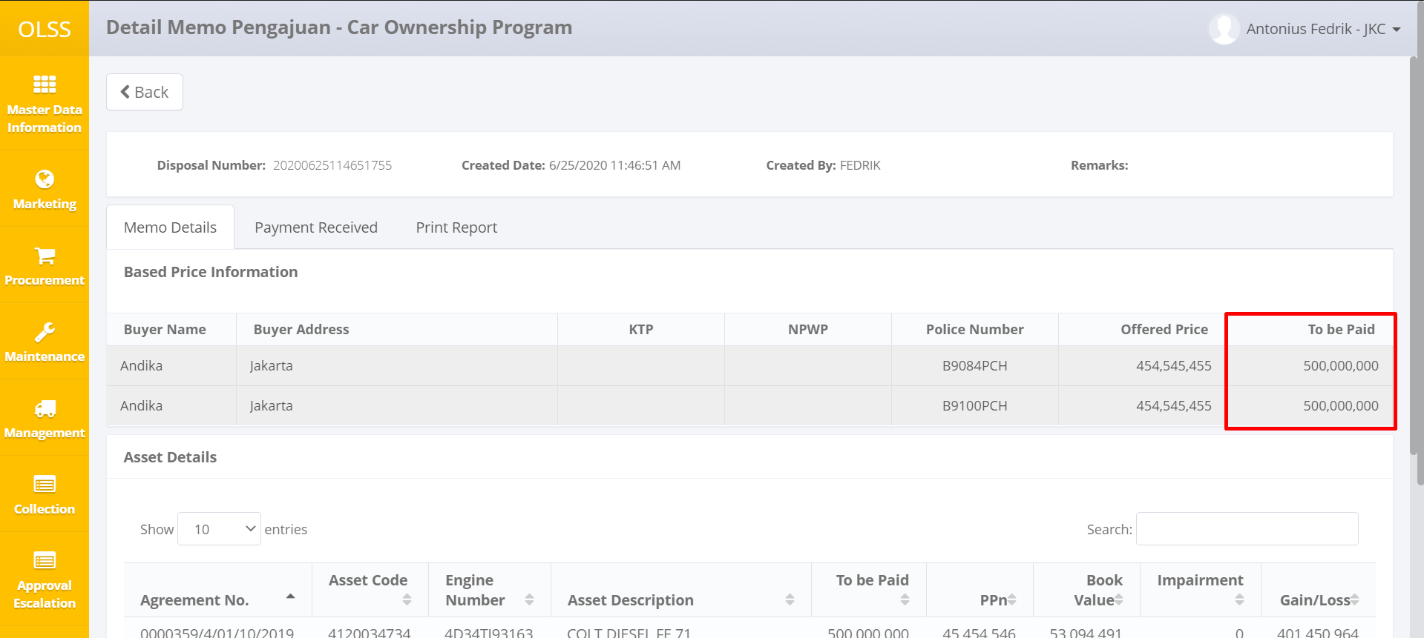

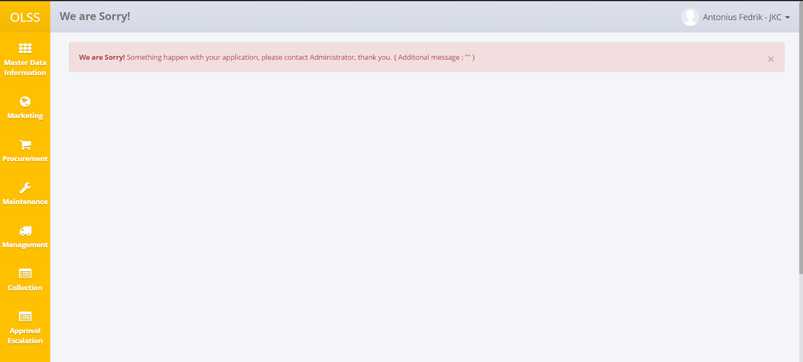Bug After Deployment